OS jackfruit stuff
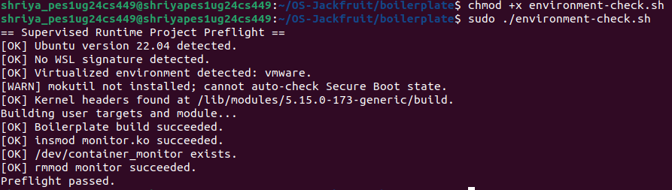
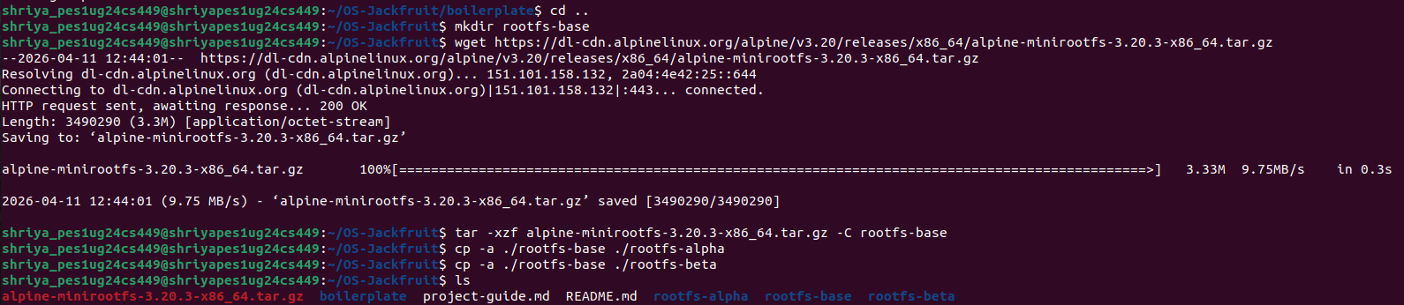
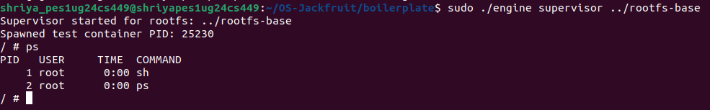
Multi-container launch
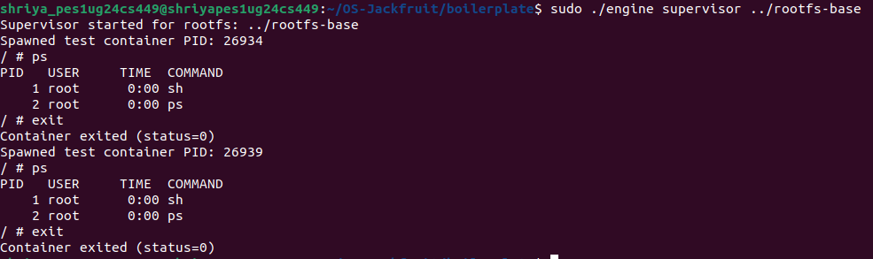
Multi-container supervision
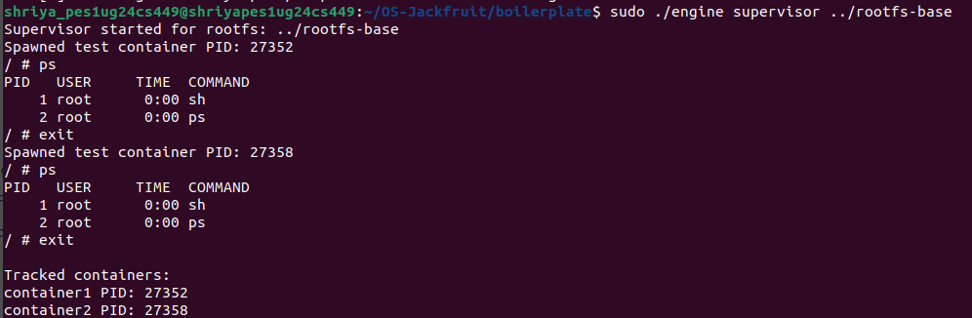

Below
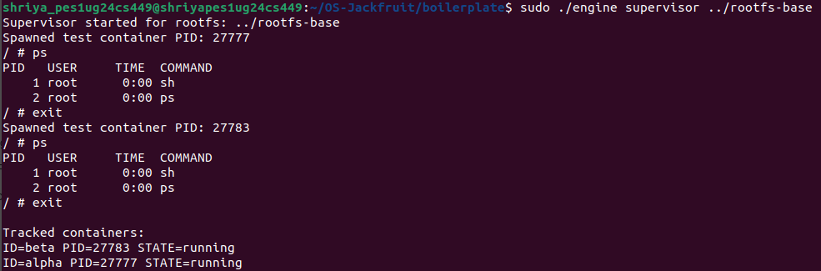

Client–Server IPC using Unix Domain Sockets
Below
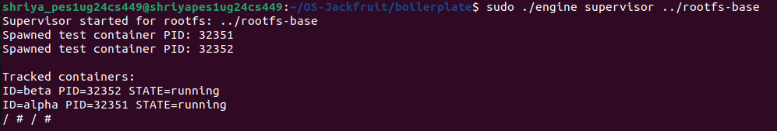
Below
IPC part – II
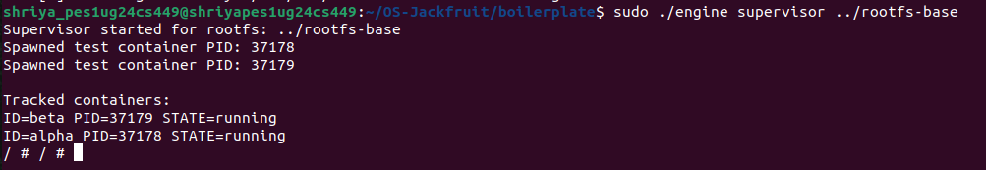
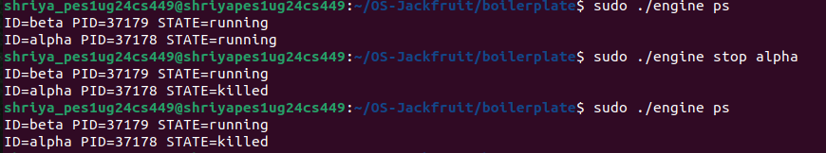

How to exit:
ps -ef | grep supervisor
sudo kill -9 37178

Change bounder_buffer push and pop for the last part
Below
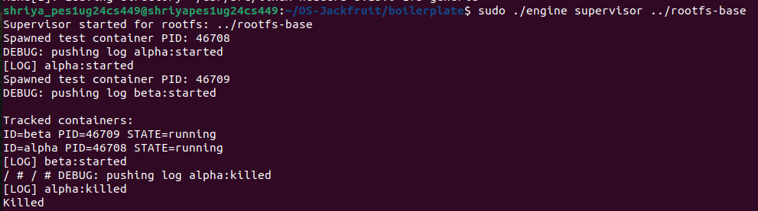

Final output: (Don’t know yet, to paste or not to)
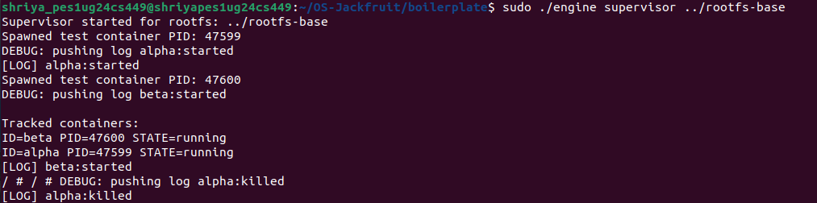
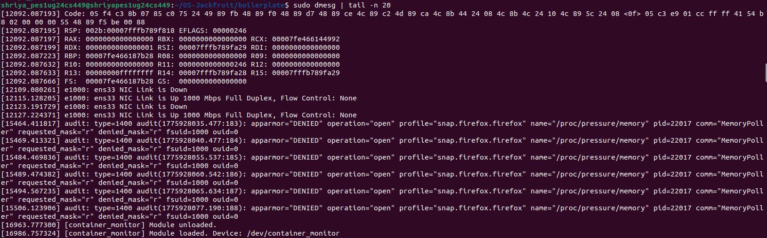
Below
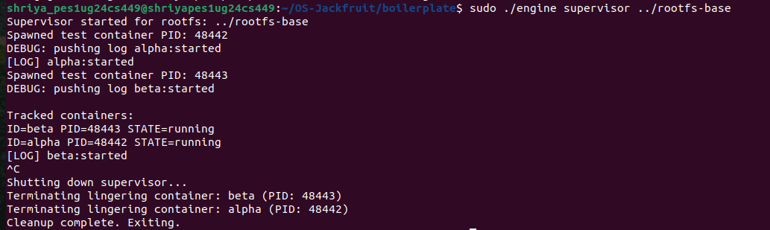
Soft-limit warning and hard-limit warning
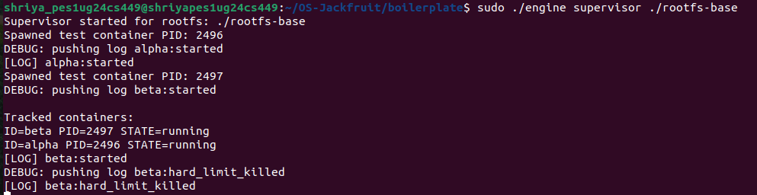
Below
Below
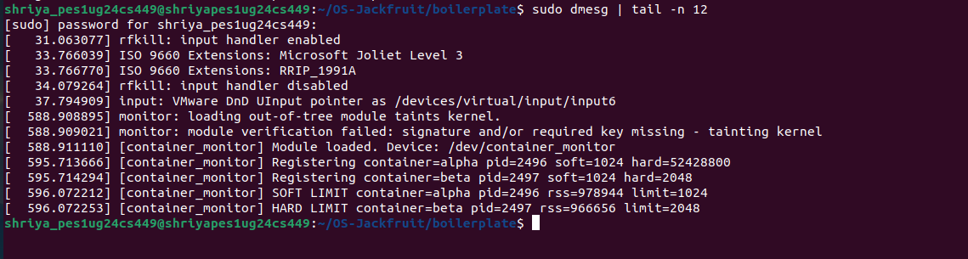

Winner
Below
Alpha has more priority
Below
